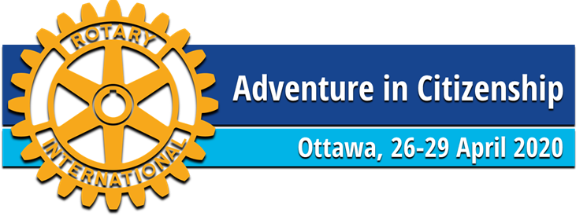

BILLETING OVERVIEW

The Rotary Club of Ottawa’s Adventure in Citizenship 4-day program is designed to develop the leadership potential of outstanding senior high school students. It is an exceptional opportunity for the students to explore our Canadian identity, shared values and the implications of the freedoms we all enjoy as Canadians. Students are individually selected and sponsored by their local Rotary Clubs.

For over sixty nine years, over one hundred homes in Ottawa are opened to participants of Rotary Adventure in Citizenship each year. The Host families learn about youth from different parts of Canada, the leadership potential of our young Canadians and Rotary’s efforts to develop this leadership potential. The Rotary Club of Ottawa is dedicated to continuing the billeting of students in order that they learn more about the citizens of Ottawa while enjoying our warm hospitality.

Our Philosophy: The Rotary Club of Ottawa has established a reputation as a community service organization which sets high standards for its members and leaders. Additionally, the club pursues high standards in the programs and services it delivers. In an effort to ensure these standards are maintained, we introduced the “buddy system”, a minimum of two same sex students in each Host home. It is our aim to protect and encourage the development of youth and the good image of The Rotary Club of Ottawa.

The Host Family’s Responsibilities: The main responsibilities of a Host Family is to provide bed and breakfast and to ensure that your guests are transported to the morning assembly point and are picked up in the evening. If transportation assistance is required, we can help.

We would ask your consideration of the following items:

- a separate bed, sleeping bag, etc. should be available for each student; (we know that girls will share a queen bed, however boys will not).

- ensure adult supervision when the student is in your home

2020 ADVENTURE IN CITIZENSHIP – TENTATIVE TRANSPORT SCHEDULE FOR HOST FAMILIES

Saturday, April 25th

Meet student(s) at location and time to be specified (airport, bus/train station) and host them Saturday evening.

Sunday, April 26th

08:30 a.m. Deliver student(s) to Library and Archives Canada (395 Wellington)
08:00 p.m. Pick up student(s) at Loblaw’s LCBO/ TD Canada Trust Parking Lot (64 Isabella Str.)

Monday, April 27th

7:15 a.m. Deliver student(s) to Parliament Hill
8:00 p.m. Pick up student(s) - Sala San Marco Banquet Hall (215 Preston Str.)

Tuesday, April 28th

8:00 a.m. Deliver student(s) to Ottawa University
10:00 p.m. Pick up student(s) at Sala San Marco Banquet Hall (215 Preston Str.)

Wednesday, April 29th

8:15 A.M. Deliver student(s) to Library and Archives Canada (395 Wellington
11:30 A.M. Join us for the Closing Luncheon – Shaw Centre

Contact:
Margot Nicholls
Program Coordinator
Rotary Adventure in Citizenship Program 2020
613-860-1521 admin@rotaryottawa.com

